1. 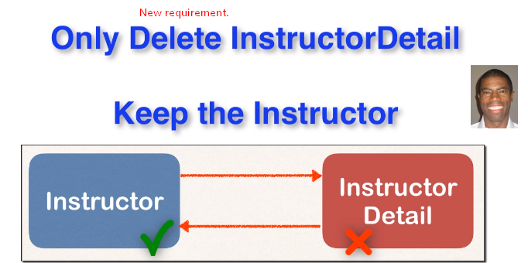
2. 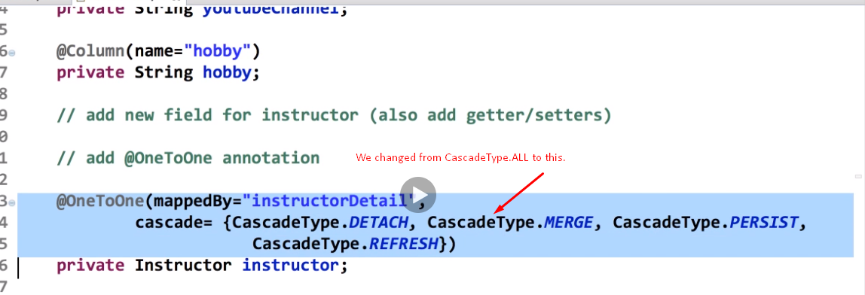++++++++++++++++++++++++++++++++++++++++++++++++

++++++++++++++++++++++++++++++++++++++++++++++++++

1. 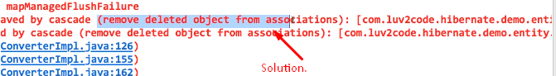
2. +++++++++++++++++++++++++++++++++++++++++++++++++++++
3. 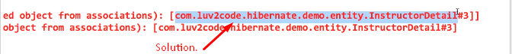
4. 